REPORT NAME: To Do Manager.

INTRODUCTION:

To Do Manager Application is a system it helps user to plan his day. A list of the tasks that you have to do, or things that you want to do. Each day user can set some task as a to-do list as possible.A user can add task,delete task,done task,clear task and add different cagtegory,delete category,clear category etc.After completing his all task he can clear all task.

THEORY:

In this To Do Manager Application I use some OOP features like Class,Object,Data Encapsulation, Inheritance, Operator Overloading and some build in OOP features like file object,vector etc.

Here are some details which class,object,inheritance I use in this application :

Class:

1.Category

2.Task

3.ToDoManager

4.User

Object:

1.User Class ‘user’ object

2.ToDoManager Class ‘todo’ object

3.Category Class Vector ‘cate’ object

4.Task Class vector ‘task’ object

Inheritance: Task Class inherit Category class properties.

Features Details:

1.At first open the To Do Manager Application if you are new user in this application then you need to create an account and login using your account information.

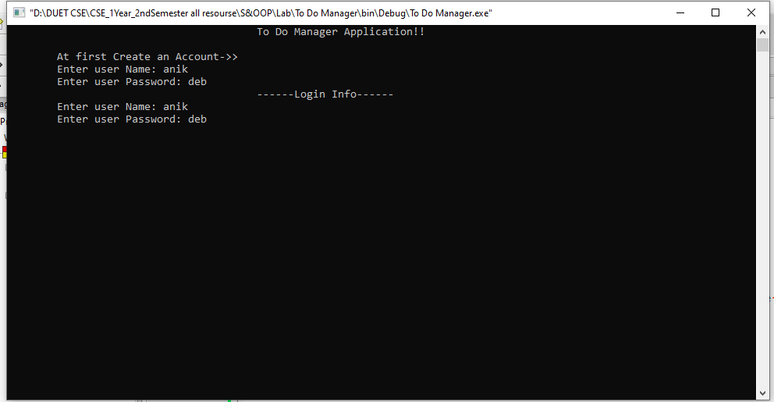

2.After that, you need to create some category “Just Enter for end input”.

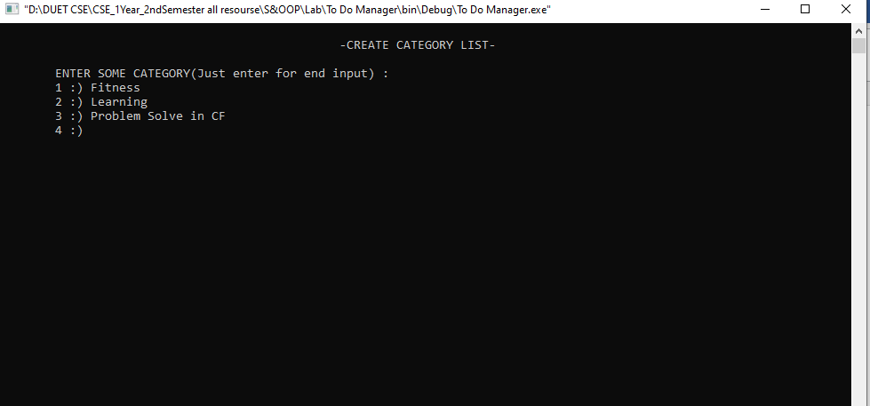

3.Now you need to create some Task “Just Enter for end input”.

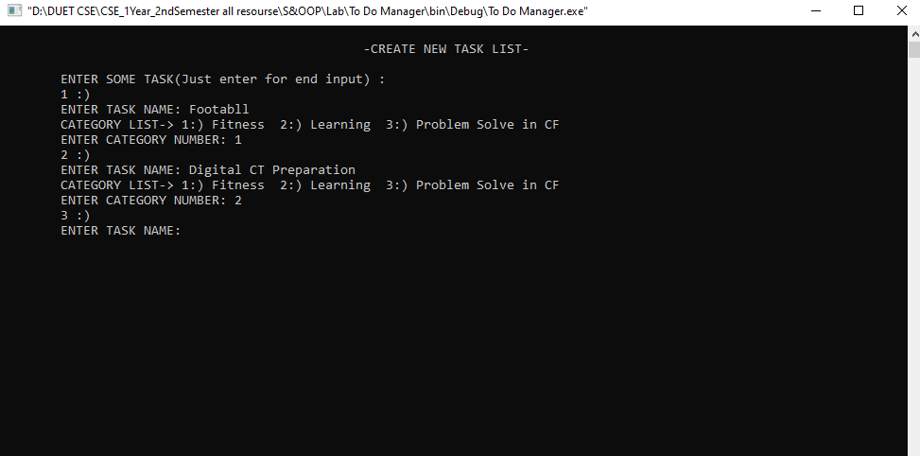

4.After that,This is your To Do List and Control Panel.

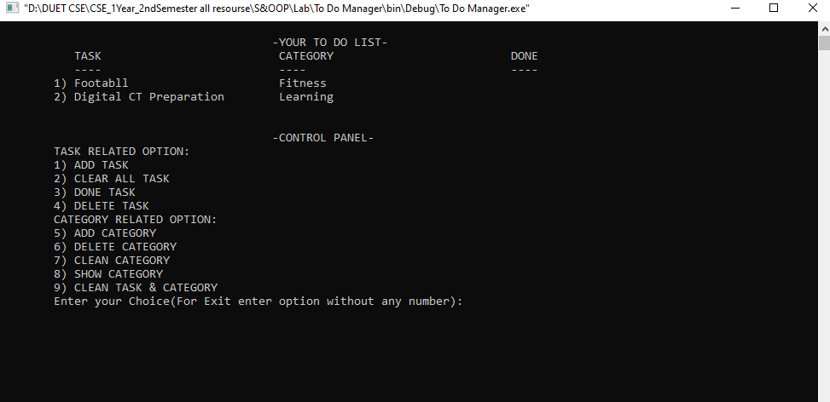

5.If you are old user in this application then login using your account information and you directly throw

your To Do List and Control Panel.

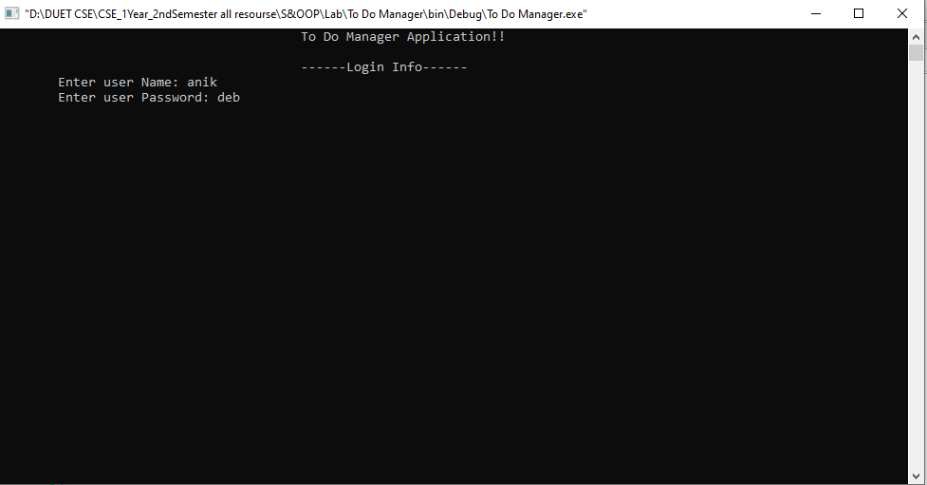

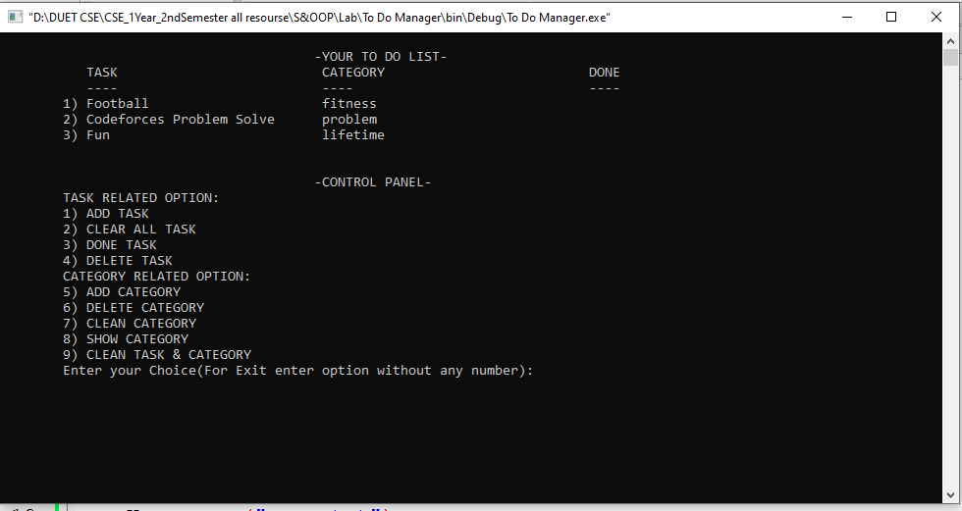

6.The Add Task option is used for creating some new task enter 1 for choose this option.You need to specify the Task name and Task Category.”Just Enter for end input”.

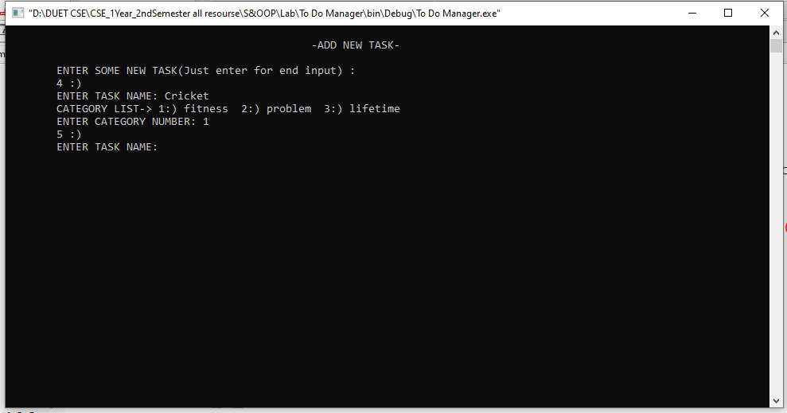

7.For delete all task you have to choose option number 2 (Clear All Task).After that,again you need to input some task.

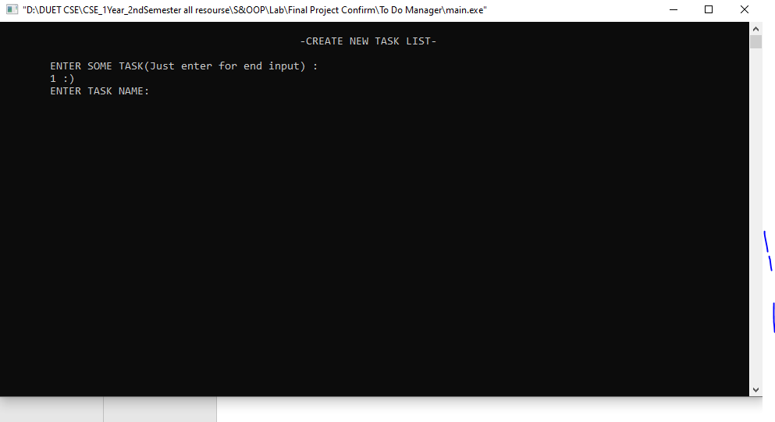

8.If you need to Done one task choose option number 3 then enter task number.

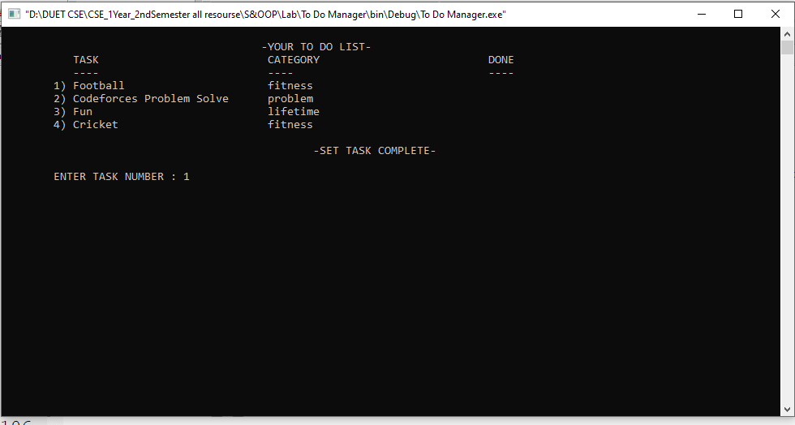

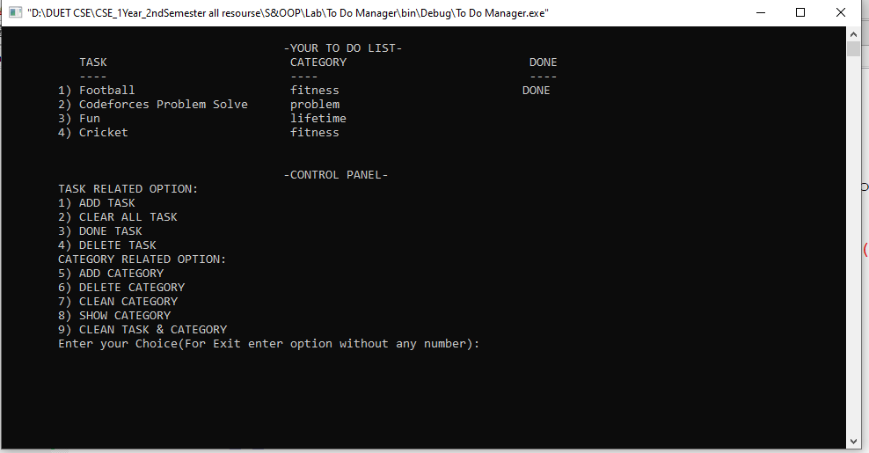

9.For delete task choose option number 4 and then enter task number.

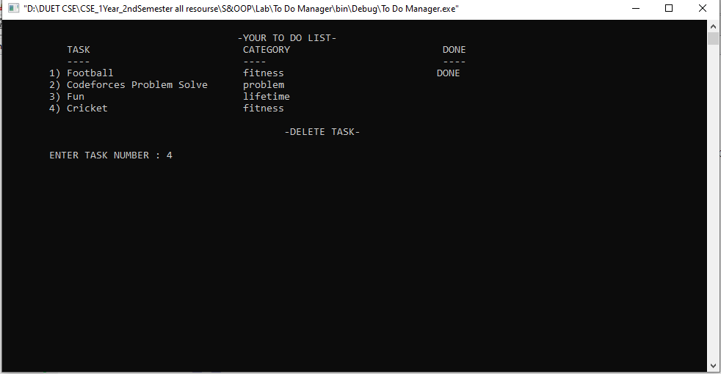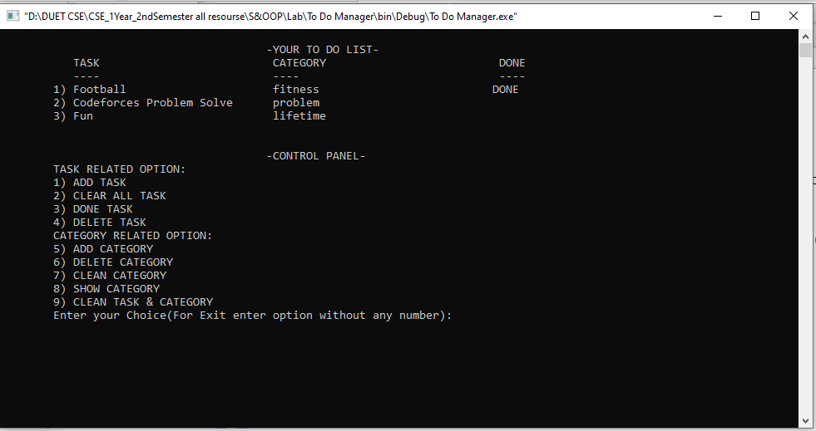

10.The Add Category option used for creating some new category.”Just enter for end input”.

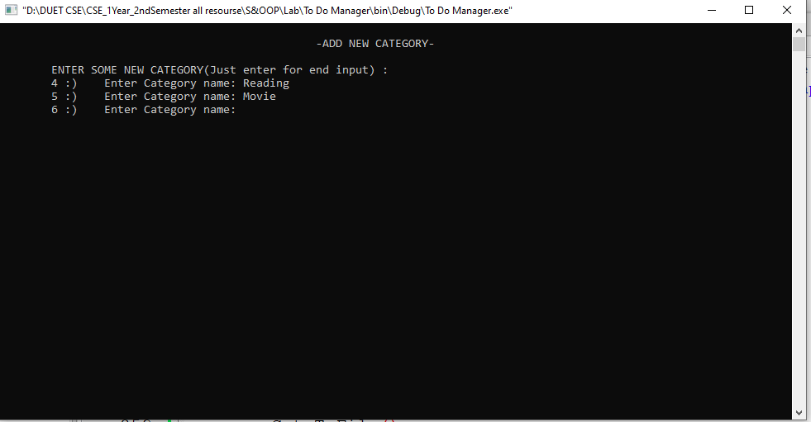

11.The Delete Category option is used for delete one Category.

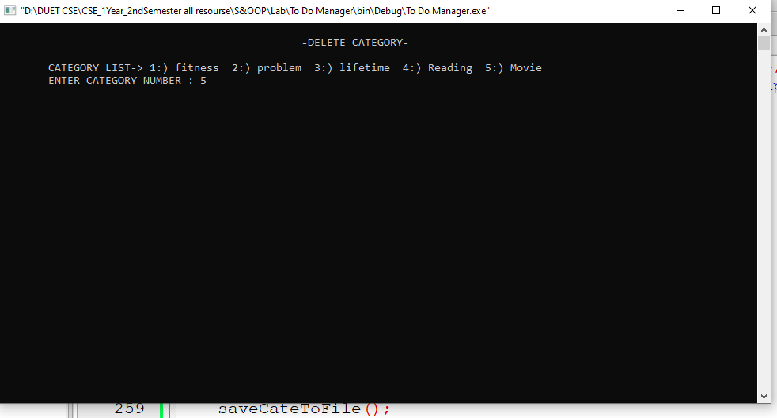

12.The Show Category option is used for show all category.

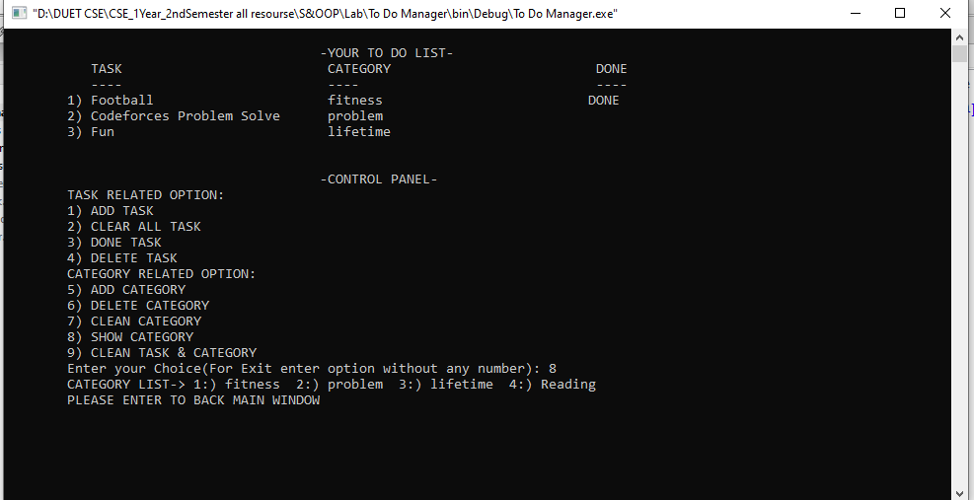

13.The Clean Task & Category option is used for delete all task and category.After that, again you need to add some category then some task.

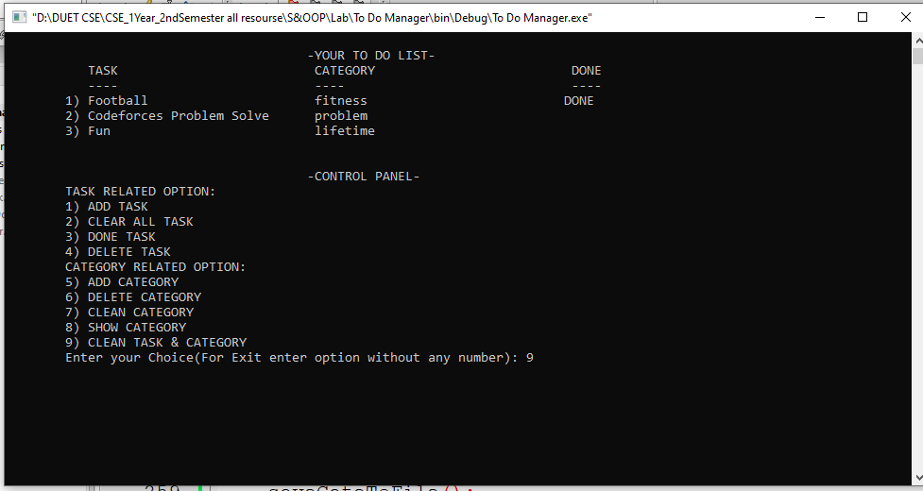

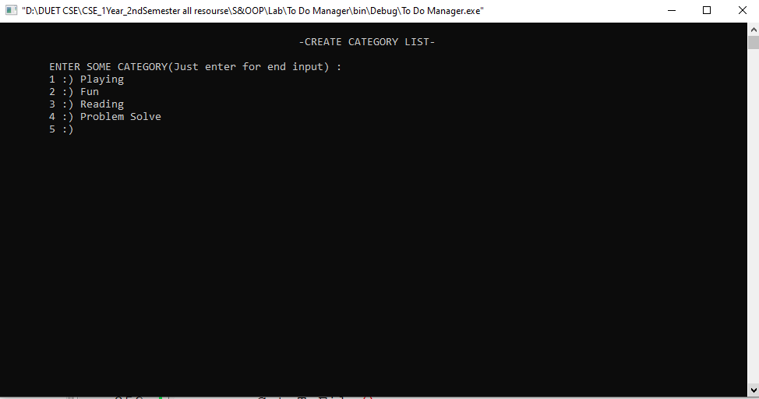



14.If you enter wrong user name or password then the application give you create account interface for creating again an account.

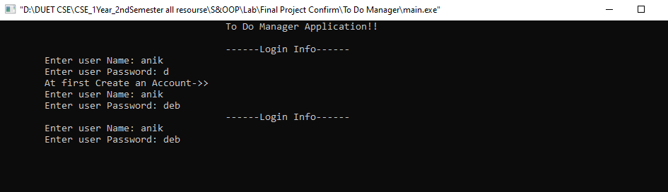

Class Diagram:

